Interaction Diagrams
• An interaction diagram shows an interaction, consisting of a set of objects and their relationships, including the messages that may be dispatched among them

• Interaction diagrams commonly contain Objects, Links, Messages

• interaction diagrams are used to model the dynamic aspects of a system

• An interaction diagram is basically a projection of the elements found in an interaction.

• It may contain notes and constraints
Sequence Diagrams
• A sequence diagram is an interaction diagram that emphasizes the time ordering of messages .
• Graphically it is a table that shows objects arranged along the X axis and messages ordered in increasing time along the Y axis.
lifelines are shown as a box with a dashed line descending from the center of the bottom edge. What this means is that the lifeline represents a specific instance of a class in a sequence diagram.

finding objects from the flow of events and place those objects that participate in the interaction at the top of your diagram, across the X axis, object that initiates the interaction at the left, and increasingly more subordinate objects to the right .
• place the messages that these objects send and receive along the Y axis, in order of increasing time from top to bottom

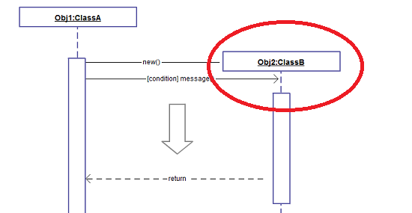

To show an object or lifeline sending a message to another object, you draw a line to the receiving object with a solid arrowhead (if a synchronous call operation) or with a stick arrowhead (if an asynchronous signal).
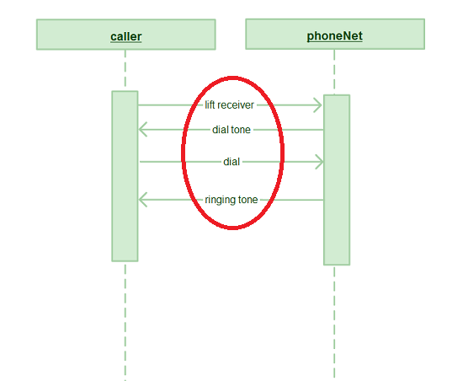

LINKS
• A link is a semantic connection among objects.

• In general, a link is an instance of an association.

• Following fig. shows, wherever a class has an association to another class, there may be a link between the instances of the two classes; wherever there is a link between two objects, one object can send a message to the other object.

LINKS

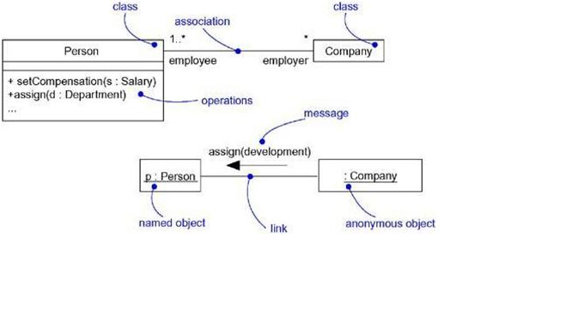

Common message symbol

Use the following arrows and message symbols to show how information is transmitted between objects. These symbols may reflect the start and execution of an operation or the sending and reception of a signal.

Symbol | Name | Description
 | Synchronous message symbol | Represented by a solid line with a solid arrowhead. This symbol is used when a sender must wait for a response to a message before it continues. The diagram should show both the call and the reply.
 | Asynchronous message symbol | Represented by a solid line with a lined arrowhead. Asynchronous messages don't require a response before the sender continues. Only the call should be included in the diagram.
 | Asynchronous return message symbol | Represented by a dashed line with a lined arrowhead.
 | Asynchronous create message symbol | Represented by a dashed line with a lined arrowhead. This message creates a new object.
 | Reply message symbol | Represented by a dashed line with a lined arrowhead, these messages are replies to calls.
 | Delete message symbol | Represented by a solid line with a solid arrowhead, followed by an X. This message destroys an object.

Sequence diagram examples

Sequence diagram of a hospital management system
Technology has completely transformed the field of medicine, as it has with most industries. A hospital information system, also known as a hospital information system, helps doctors, administrators, and hospital staff managing all of the activities and information collected at a hospital, including checkups, prescriptions, appointments, and information on the patients and their caretakers. The diagram below provides a simple view of how the primary processes operate with each other over time. You can use Lucidchart to reshape the diagram any way you choose and to share it with your colleagues or collaborators.
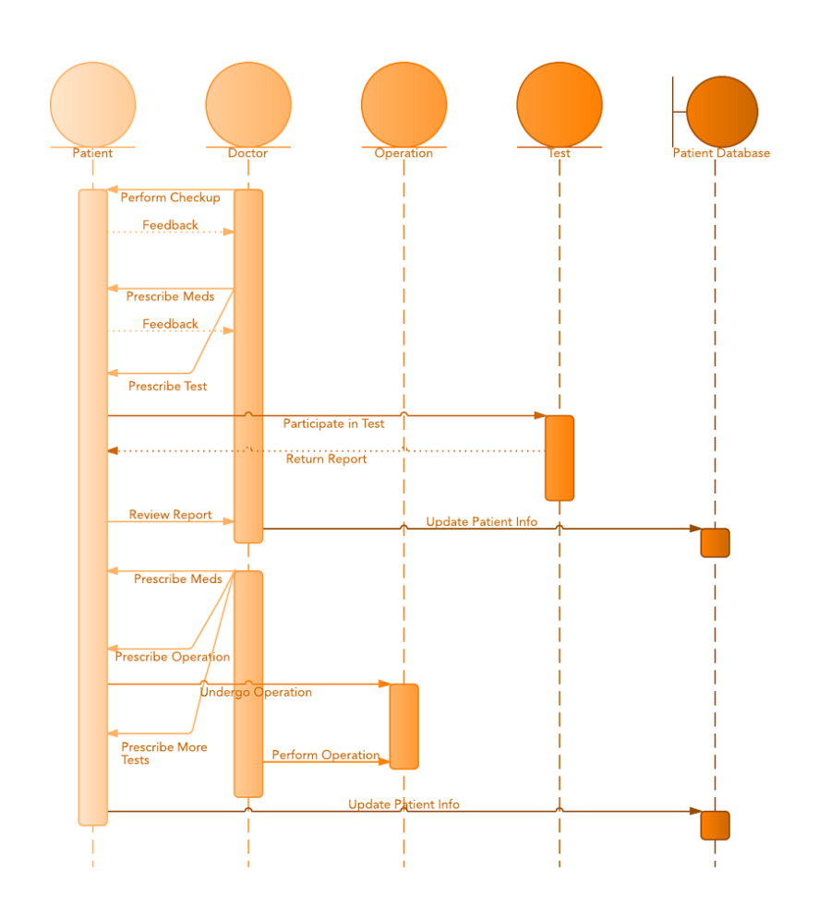
Click here to use this template

Sequence diagram for ATM systems
An ATM allows patrons to access their bank accounts through a completely automated process. You can examine the steps of this process in a manageable way by drawing or viewing a sequence diagram. The example below outlines the sequential order of the interactions in the ATM system. Just click to edit the template, and customize the sequence diagram so it suits your own needs.
